**Problem: All the mails from a specific domain (ex. email@veritas.com) are going to junk folder.**

Solution:

1. *Assume if the User email/Domain is already configured in blacklist. (accidentally).*

To remove it from the blacklist…

Email sent to you from domains, email addresses, and IPs on your blacklist will be blocked and will not be delivered to your mailbox. To manage your blacklist, do the following:

Click **Settings**, located in the upper right corner of the webmail window.

1. In the left pane, click **Spam Settings**, then click the **Blacklist** tab.
2. Click the corresponding, (like veritas.com) **Delete** button.
3. Click **Yes** to confirm you want to delete the items.
4. Click **Save**.
5. *You can override the settings by adding the email/domain to safe list.*

Email that you receive from domains, email addresses, and IPs on your safelist will bypass the spam filters, ensuring you receive email from those senders. To add a domain, email address, or IP to your safelist, do the following:

1. Click **Settings**, located in the upper right corner of the webmail window.
2. In the left pane, click **Spam Settings**.
3. Click the **Safelist** tab.

To add a domain or email address to the list:

1. Click the **Add** button.
2. Enter a domain or email address in the space provided.
3. Click the **Add** button.

**Apart from that,**

Rackspace gives you the flexibility to set your own spam preferences, if you have Cloud Admin ID (An Admin who creates the user email ids in Rackspace will have the Cloud Admin ID privileges). This includes editing and managing domain-wide spam settings, safelists, and blacklists, and the ability to override the spam filtering for the entire domain. Here is the description how to manage accomplish these tasks in the CLOUD OFFICE CONTROL PANEL.

Link: https://cp.rackspace.com/

To manage your domain-level spam settings, go to the **Domains** section of the control panel and select **Filter Settings**, **Blacklists**, or **Safelists**.

The Control panel looks like this.

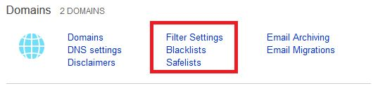

To manage individual user’s spam settings, go to the **Rackspace Email** section of the control panel and select **Filter Settings**, **Blacklists**, or **Safelists**.

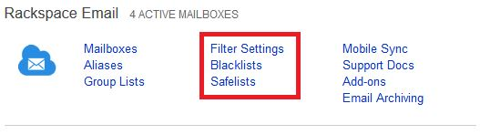

1. Select the user for which you want to update spam settings.
2. For individual mailboxes, click **Filter Settings** in the **Rackspace Email** section. For the domain, click **Filter Settings** in the **Domains** section.

In the Status section, turn the spam filtering on or off. You can also select **Exclusive** to receive email only from senders on your domain’s safelist.

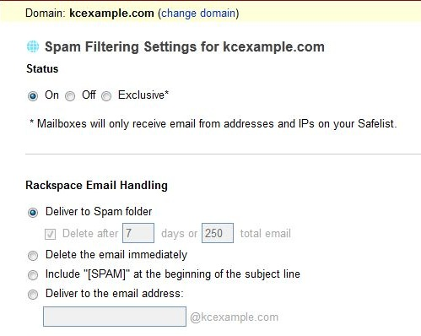

Select the preferred settings for Rackspace Email in your domain. Following is a description of each option:

* + **Deliver to Spam folder** - Spam messages are sent to the user’s Spam folder. To automatically delete messages from this folder, select the **Delete after *n* days or *n* total email** check box and enter a specified number of days, total emails, or both.
  + **Delete the email immediately** - Spam email will be deleted automatically and not delivered to the user’s mailbox.
  + **Include “[SPAM]” at the beginning of the subject line** - Spam email will be delivered to the user’s Inbox, but will include the text **”[SPAM]“** in the subject line.
  + **Deliver to the email address** - Spam messages are sent to an email address of your choice that resides on your domain.

**Manage safelists**

1. For individual mailboxes, click **Safelists** in the **Rackspace Email** section. For the domain, click **Safelists** in the **Domains** section.
2. To add a domain name or email address to the safelist, enter the domain or email address in the box, and then click **Add**.
3. To remove a domain or email address, select the name in the list and then click **Remove**. To remove all domain names or email addresses listed in the window, click **Clear**.

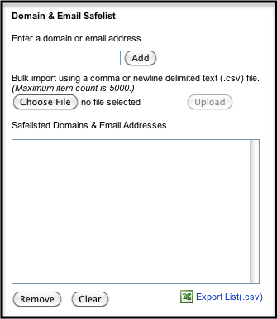

1. Click **Save**.

Hope these steps will help you.